Works List
Office Gallery:

1. | 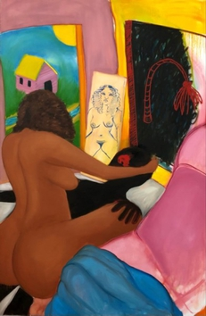 |  | Monica Hernandez  ghosted, 2019  oil on canvas  72 x 48 in (182.9 x 121.9 cm)
2. | 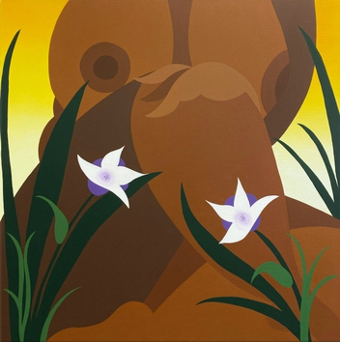 |  | Bianca Nemelc  Flowers in Bloom, 2020  acrylic on canvas  40 x 40 in (101.6 x 101.6 cm)

Upstairs Gallery:

1. | 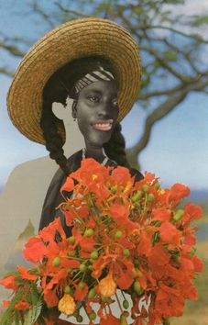 |  | Joiri Minaya  Yoowiri or Girl with poinciana flowers, 2020  Archival pigment print  17 x 11 in
2. | 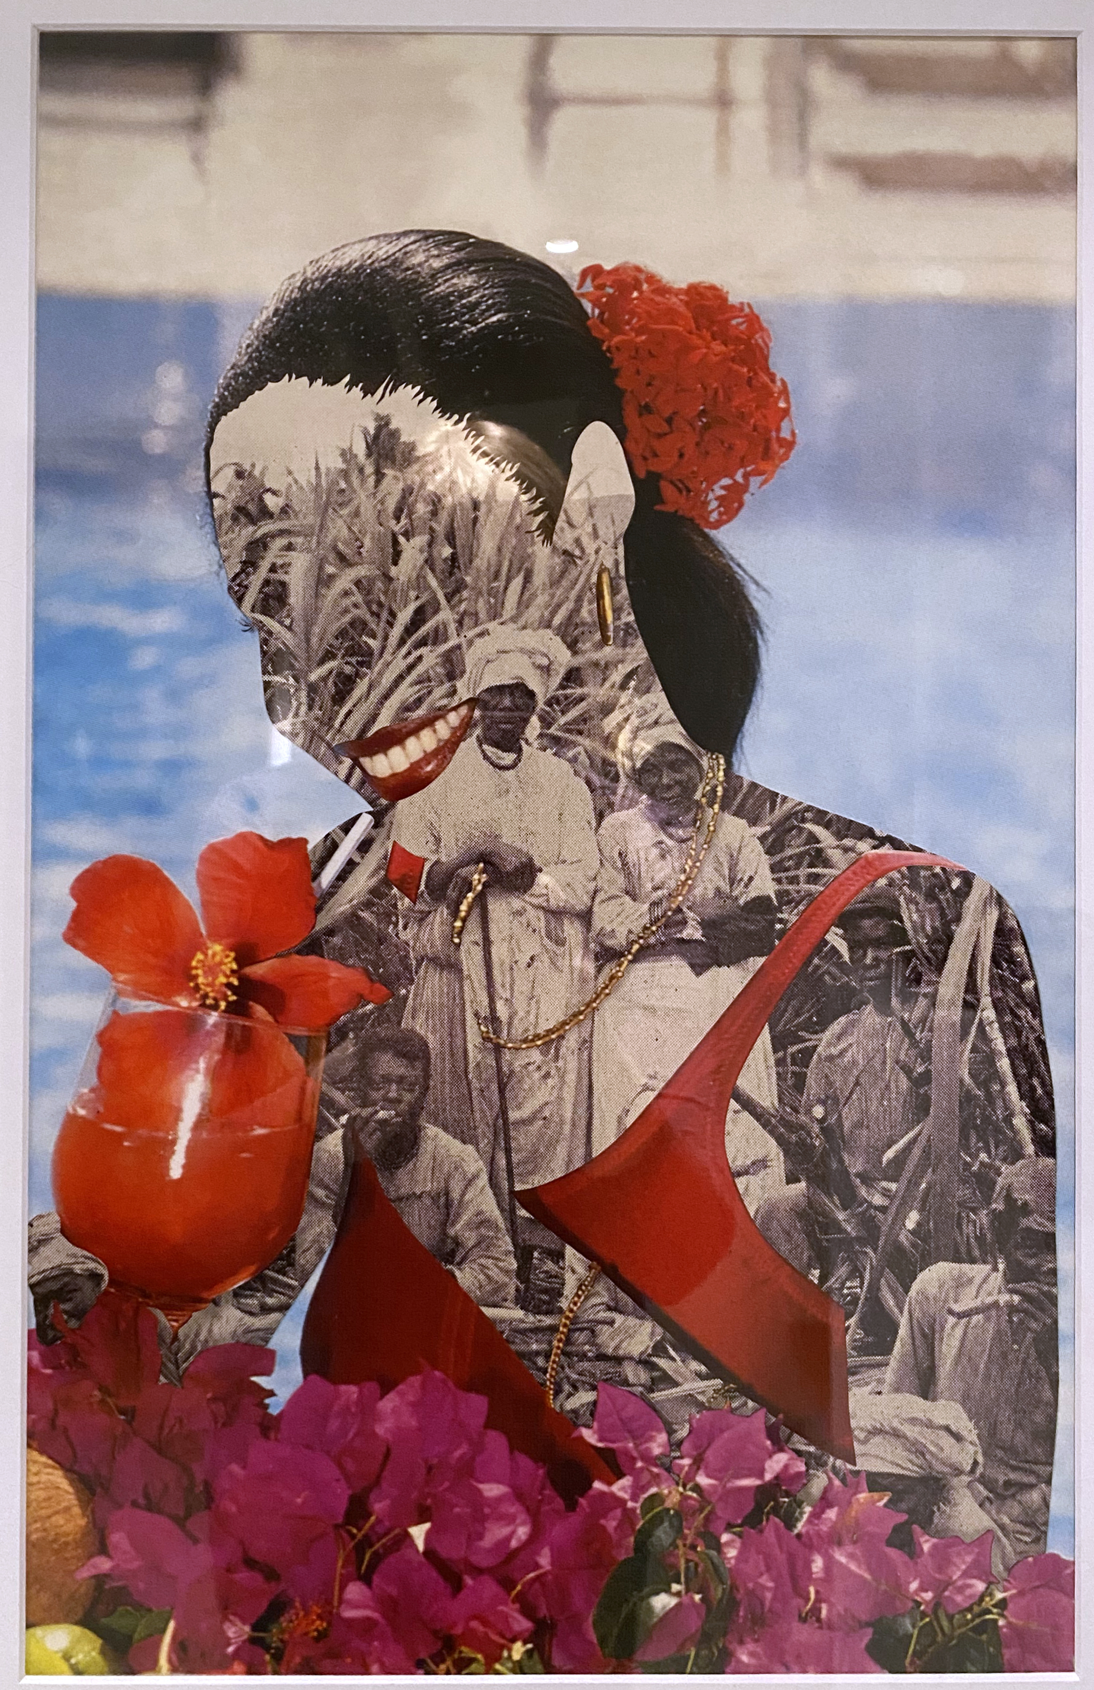 |  | Joiri Minaya  Untitled 1, 2020  Archival pigment print  17 x 11 in
3. | 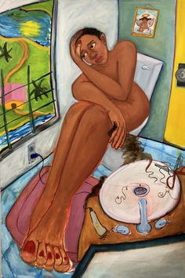 |  | Monica Hernandez  dumped, 2020  oil on canvas  72 x 48 in (182.9 x 121.9 cm)
4. | 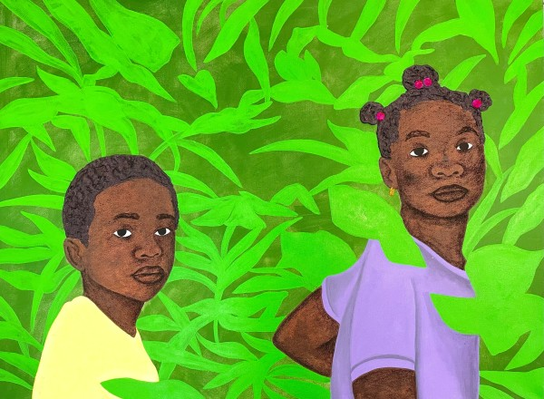 |  | Tiffany Alfonseca  No confío en tu mirada, 2021  acrylic, glitter, rhinestones, and charcoal on canvas  30 x 40 inches (76.2 x 101.6 cm)
5. | 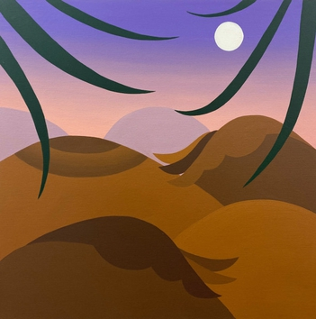 |  | Bianca Nemelc  Dusk Beyond The Horizon, 2021  acrylic on canvas  30 x 30 in (76.2 x 76.2 cm)
6. | 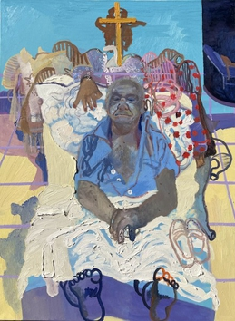 |  | Veronica Fernandez  Four Branches, 2021  oil on canvas  40 x 30 in

Downstairs Gallery:

1. | 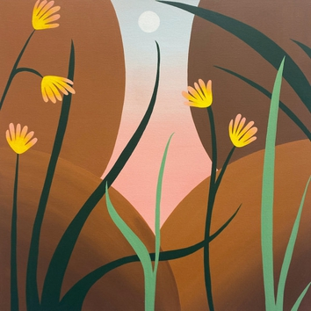 |  | Bianca Nemelc  Dawn Between Two Thighs, 2021  acrylic on canvas  30 x 30 in (76.2 x 76.2 cm)
2. | 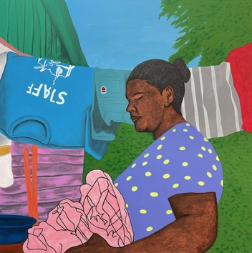 |  | Tiffany Alfonseca  Miledy, De La Vega, 2021  acrylic, charcoal, glitter, on canvas  48 x 48 in (121.9 x 121.9 cm)
3. | 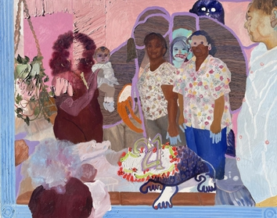 |  | Veronica Fernandez  Between This and Myself (You Never See Me), 2021  oil on canvas  48 x 60 in
4. | 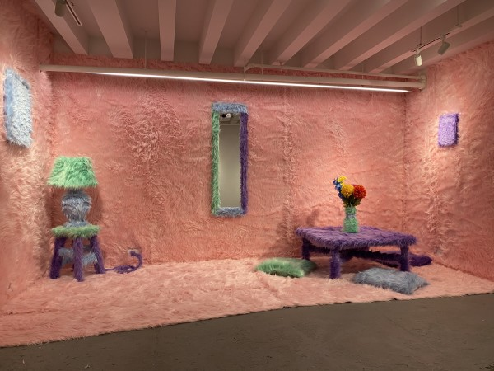 |  | Uzumaki Cepeda  Stuck Between a Rock and a Hard Place, 2021  fur on found objects  dimensions variable
5. | 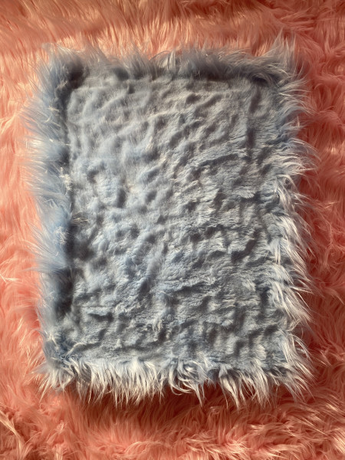 |  | Uzumaki Cepeda  Blue Painting, 2021  fur on found object  20 x 16 in (50.8 x 40.6 cm)
6. | 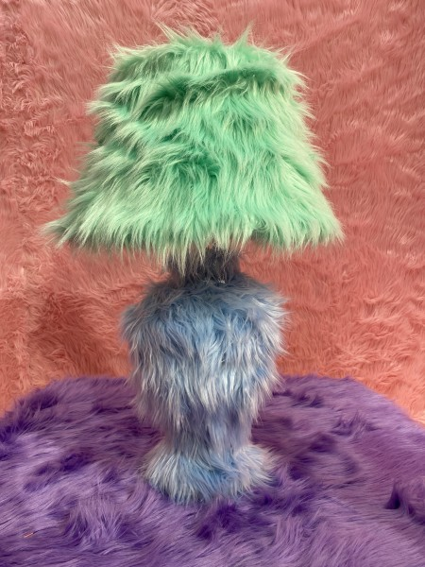 |  | Uzumaki Cepeda  Lamp, 2021  fur on found object  16 x 28 inches (40.6 x 71.1 cm)
7. | 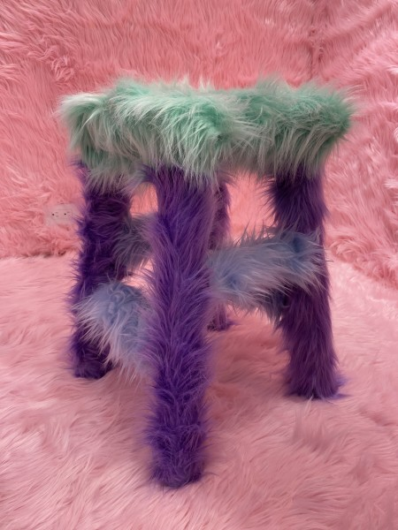 |  | Uzumaki Cepeda  Stool, 2021  fur on found object  19.5 x 12 x 12 inches (49.5 x 30.5 x 30.5 cm)
8. | 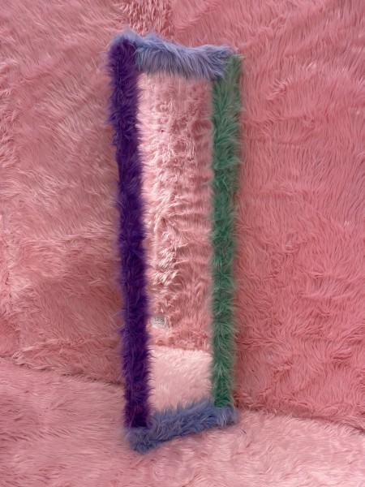 |  | Uzumaki Cepeda  Mirror, 2021  fur on found object  52 x 15 inches (132.1 x 38.1 cm)
8. | 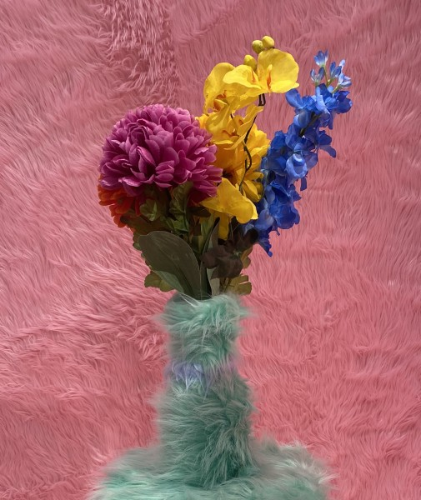 |  | Uzumaki Cepeda  Flower Vase, 2021  fur on found object  22 x 4 inches (55.9 x 10.2 cm)
10. | 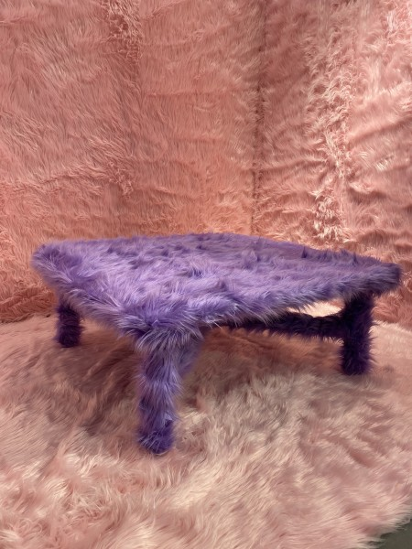 |  | Uzumaki Cepeda  Table, 2021  fur on found object  15 x 36 x 36 inches (38.1 x 91.4 x 91.4 cm)
11. | 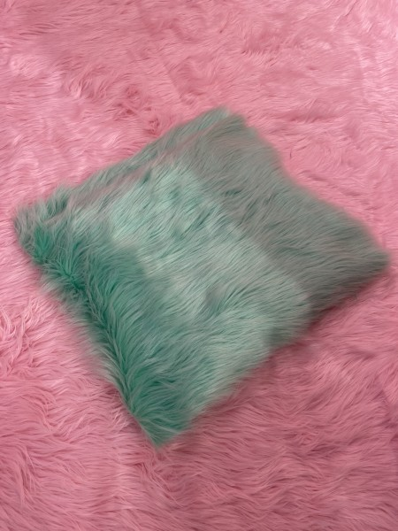 |  | Uzumaki Cepeda  Green Pillow, 2021  fur on found object  21 x 17 inches (53.3 x 43.2 cm)
12. | 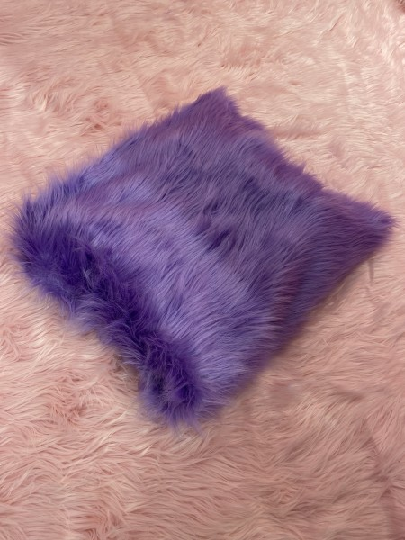 |  | Uzumaki Cepeda  Purple Pillow, 2021  fur on found object  20 x 19 inches (50.8 x 48.3 cm)
13. | 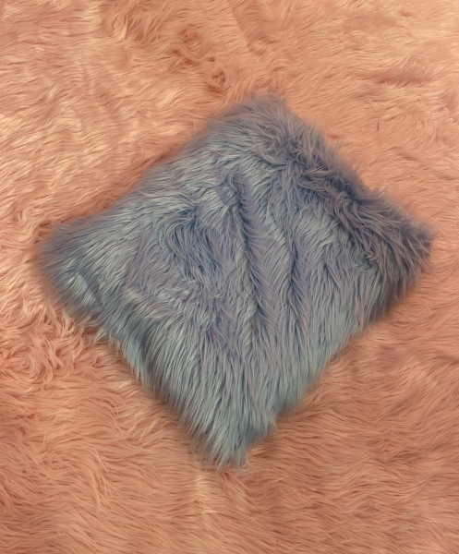 |  | Uzumaki Cepeda  Blue Pillow, 2021  fur on found object  18 x 16 inches (45.7 x 40.6 cm)
14. | 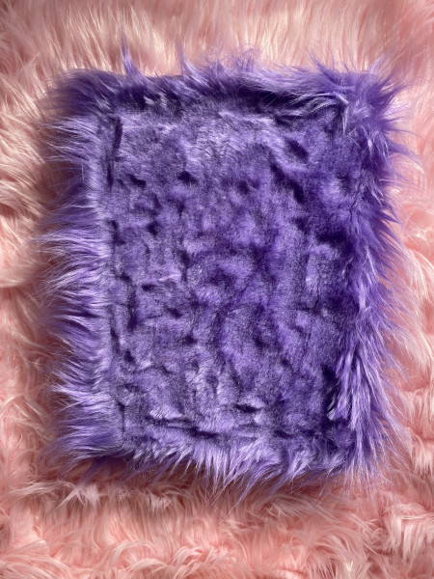 |  | Uzumaki Cepeda  Purple Painting, 2021  fur on found object  12 x 9 in (30.5 x 22.9 cm)
15. | 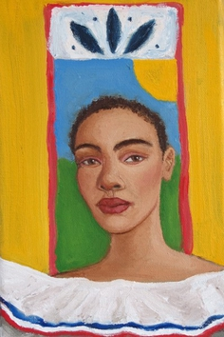 |  | Monica Hernandez  bandera, 2021  oil on canvas  9 x 6 in (22 x 15 cm)
16. | 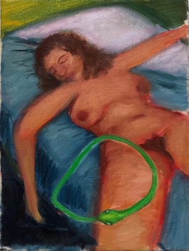 |  | Monica Hernandez  out of bounds, 2020  oil on canvas  12 x 9 in (30.5 x 22.9 cm)
17. | 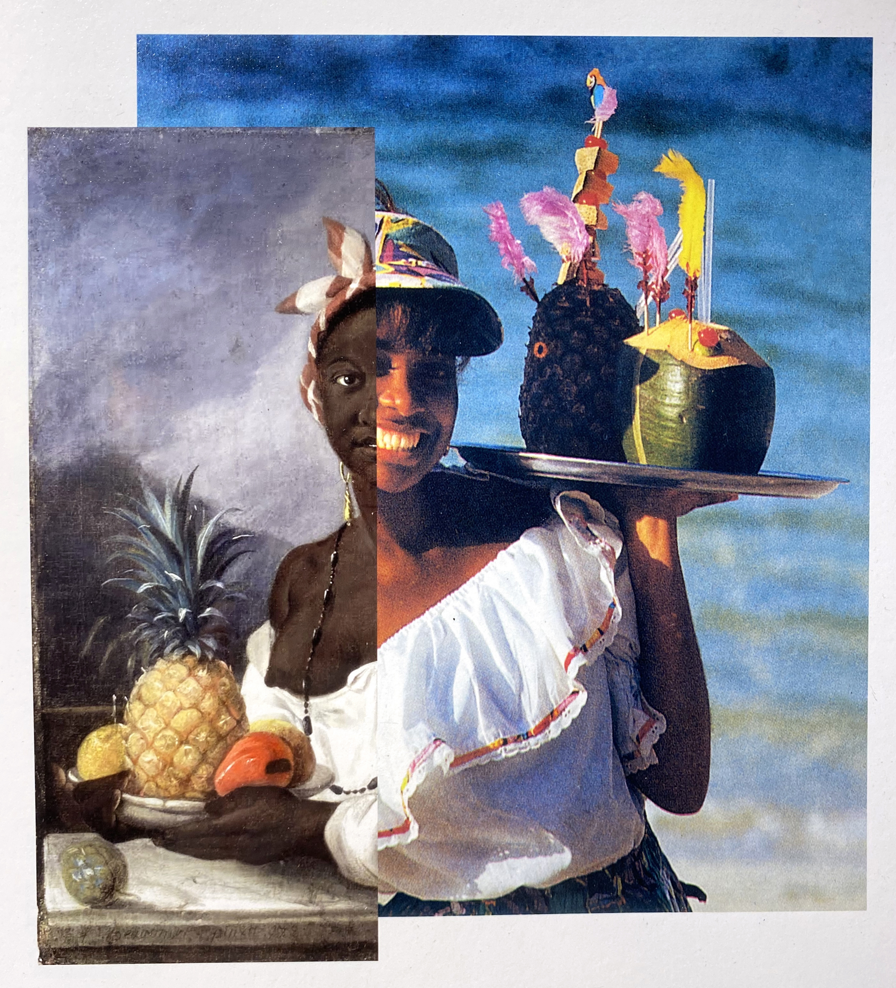 |  | Joiri Minaya  Untitled 2, 2020  Archival pigment print  10 x 10 in
18. | 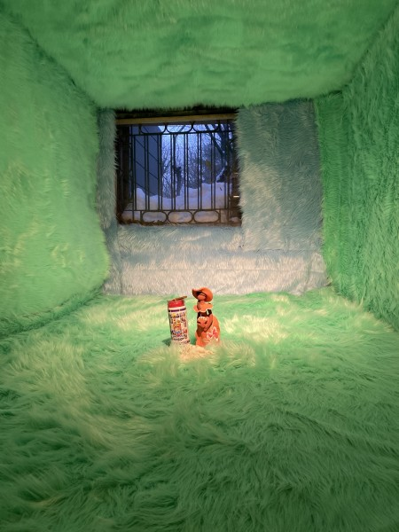 |  | Uzumaki Cepeda  el pasado me trajo aqui, 2021  fur and found objects  dimensions variable
19. | 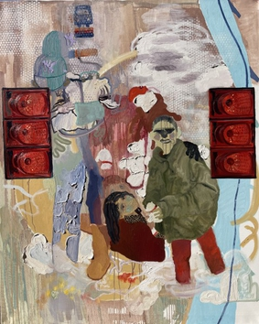 |  | Veronica Fernandez  Pockets of Snow (Lost Wallet), 2020  oil on canvas  60 x 48 in
20. | 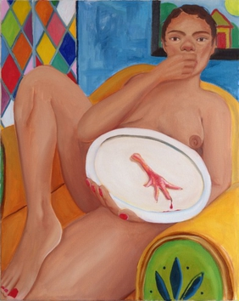 |  | Monica Hernandez  clipped, 2021  oil on canvas  30 x 24 in (76.2 x 61 cm)
21. | 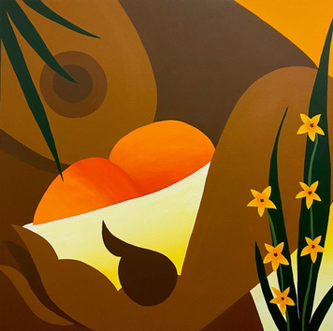 |  | Bianca Nemelc  Fruiting Body, 2020  oil on canvas  40 x 40 in (101.6 x 101.6 cm)
22, | 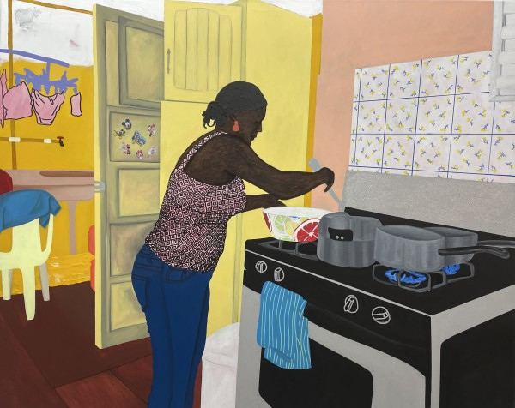 |  | Tiffany Alfonseca  Romi, 2021  glitter, acrylic paint, and charcoal on stretched canvas  48 x 60 inches (121.9 x 152.4 cm)
23. | 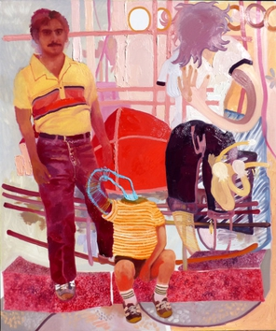 |  | Veronica Fernandez  Growing With Risks (Three), 2020  oil on canvas  60 x 48 in
24. | 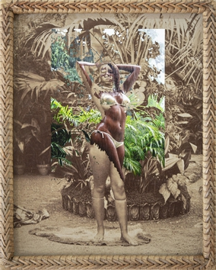 |  | Joiri Minaya  Continuum, 2020  archival pigment print  14 x 11 in

